100 Ways to be successful in the Earth Science

1. The same substance always has the same density
2. As pressure increases, density increases
3. As temperature increases, density decreases
4. Water expands when it freezes
5. Most changes are cyclic
6. Water is most dense at 4ºC, when it is a liquid
7. The universe began with a big explosion--"The Big Bang"
8. The best model of the Earth is a sphere
9. The altitude of Polaris equals your latitude
10. Our solar system is located on one of the outer arms of our Milky Way Galaxy
11. Latitude lines go east-west, just like the equator, but measure distances north or south.
12. Longitude lines go north-south, but measure distances east or west.
13. Longitude is based on observations of the sun
14. Use the reference tables
15. The closer the isolines (contour-isobar-isotherms-) are the steeper the slope or gradient
16. The earth rotates from west to east (24 hours)
17. The earth revolves counterclockwise (365 1/4 days)
18. All celestial objects appear to rise in the east and move west
19. The moon has phases because it revolves around the earth (remember, though, that half is always lit)
20. Planets appear to go backwards (retrograde) as the earth passes them in space
21. Summer solstice is June 21st
22. Winter solstice is December 21st
23. Equinoxes: March 21st September 23rd
24. Equator always has 12 hours of day-light
25. The lower the altitude of the sun, the longer the shadow it casts
26. Foucault's pendulum and the coriolis effect prove the earth rotates
27. Earth is closest to the sun in January
28. The closer a planet is to the sun the higher it's velocity
29. Use the reference tables!
30. Remember to use the reference tables.
31. Black and rough surfaces are the best absorbers and radiators
32. The half-life of a radioactive element can't be changed
33. Ocean crust is thin and made of basalt
34. Continental crust is thick and made of granite
35. Energy moves from source to sink: high to low
36. Mountains form by uplift, folding and faulting
37. Chemical weathering occurs mostly in warm, humid climates
38. Physical weathering occurs mostly in cold, humid climates (good for frost wedging)
39. Air moves clockwise and outward around a high
40. Air moves counterclockwise and inward around a low
41. Good absorbers of radiation are good radiators
42. Hottest part of the year is in July
43. Hottest part of the day is after 1:00p.m.
44. As temperature increases, air pressure decreases
45. As moisture increases, pressure decreases
46. Air pressure decreases with altitude
47. Highs are cool and dry; lows are warm and wet
48. Wind is due to air pressure differences
49. Wind blows from high to low pressure
50. Wind is named from the direction that it is coming from
51. The accepted value is the correct answer. The measured value is the guess.
52. The closer the air temperature is to the dew point the greater the chance for precipitation
53. Weather moves from west to east in the United States
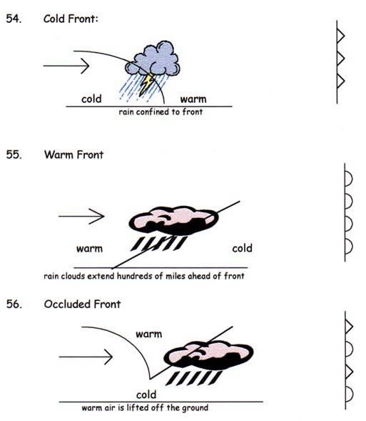
57. Cold fronts move the fastest
58. Porosity does not depend on particle size
59. As particle size increases, permeability increases
60. Capillarity increases when particle size decreases
61. Ep (potential evapotranspiration) depends on temperature
62. Dynamic equilibrium means balance
63. Increase in latitude and altitude have the same affect on climate
64. Vertical rays (overhead sun) can only occur between 23 1/2ºN and 23 1/2ºS
65. Index fossils are good time markers (widely spread, lived a short time)
66. Air cools and expands as it rises
67. Large bodies of water moderate temperature (smaller temperature range)
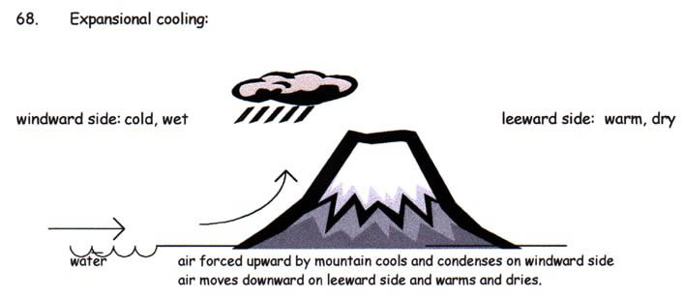
69. Gravity causes most erosion
70. Streams are the number one agent of erosion
71. Stream velocity depends on slope and discharge
72. Velocity is fastest on the out side of meander bend
73. Heavy, round, and dense particles settle out first
74. Graded bedding (vertical sorting): biggest sediments are on bottom
75. Glacial sediments are unsorted with scratches in a U-shaped valley
76. Sedimentary rocks may have flat layers - most likely to have fossils
77. Igneous rock: cools fast-small crystals; cools slow-large crystals
78. Metamorphic: banded-distorted structure
79. Mineral properties depend on internal atomic arrangement
80. Calcite fizzes with acid
81. Isostasy: earth's crust in equilibrium (uplift & subsidence)
82. Mid-ocean ridge - new earth being created-sea floor spreading
83. Trenches - earth being destroyed-subduction zone
84. P-waves are faster than S-waves
85. P-waves - solids & liquids can pass through -- S-waves solids only
86. You need 3 seismometer stations to plot an earthquake
87. Undisturbed layers - bottom layer is oldest (this is the Law of Superposition)
88. Intrusion and faults are younger than the rock they are in
89. Unconformity means erosion (time gap in the layers)
90. Arid (dry) landscape: steep slopes with sharp angles
91. Humid (wet) landscape: smooth with rounded slopes
92. When in doubt, see if the reference tables will help
93. Uranium ²³⁸ is used to date old rocks
94. Carbon ¹⁴ is used to date recent living objects
95. Convection currents in the mantle move plates
96. Always try to eliminate two answers
97. When a rock is broken into smaller pieces, surface area increases and weathering rate increases
98. Use complete sentences for the free responses
99. Be familiar with (but don't memorize) this chart:
DATE (APPROXIMATE) | LATITUDE OF SUN'S DIRECT RAYS | DIRECTION OF SUNRISE AND SUNSET | ALTITUDE OF NOON SUN | LENGTH OF DAYLIGHT
Sept. 23 (Autumnal Equinox) | Equator (0º) | Rises due East Sets due West | 48º | 12 hours
December 21 (Winter Solstice) | Tropic of Capricorn  (23 1/2ºS) | Rises in SE  Sets in SW | 24.5º (lowest) | 8 hours  (shortest day)
March 21 (Vernal Equinox) | Equator (0º) | Rises due East  Sets due West | 48º | 12 hours
June 21 (Summer Solstice) | Tropic of Cancer  (23 1/2ºN) | Rises in NE  Sets in NW | 71.5º (highest) | 16 hours (longest day)

100. USE THE REFERENCE TABLES!

